## Setup Split Ticket on DEA

Follow the steps below to setup the Split Ticket Enhancement tool.

1. **Remote to *ttxpvhnn01* using the single sign in associated to set up enhancements**
2. **Connect using BDE Launcher**

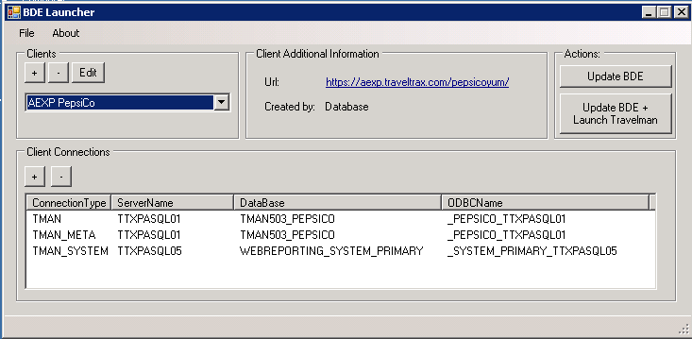

1. Select the client’s name using BDE Launcher.

* The ODBC connection string is used in the command line arguments passed to DEA.
* If the client is not in the drop down list, go to File – Import Client – select client – Import.

1. Click on the **Update BDE** button.
2. **Open the Split Ticket application**

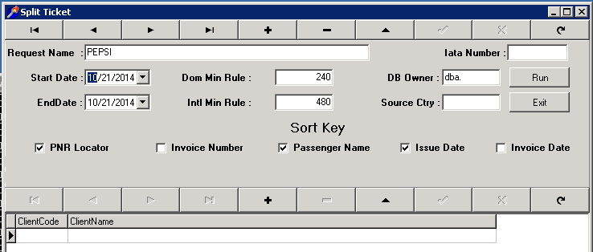

* You will need to create a request if one has not been created

1. **Create Split Ticket Request**
2. **Request Name –** Enter the client’s request name.

* Name given to the split ticketing process you want to run. It is the name that you want to associate with the IataNum you wish to process.

1. **Iata Num –** It is not required since it’s running for all records for a given timeframe.
2. **Start Date/End Date –** Add dates for the transactions processed.
3. **Domestic Minute Rule –** Time (in minutes) spent in a connecting city. It should match what is in Agency ETL (DataMan). Standard is 240
4. **International Minute Rule –** Time (in minutes) spent in a connecting city international connections. Standard is 480
5. **DBA owner –** Must have the period at the end – **dba.**
6. **Source Country –** Leave it blank since most clients have multiple countries

1. **Sort Keys –** Select the keys you want it to sort on. The system allows you to choose both issue date & invoice date, but you’re only supposed to select one of them. Recommended are bold below:

* **PNR Locator**
* Invoice Num
* **Pax Name**
* **Issue Date**
* Invoice date

1. Click the check mark.

## Command Line Options

-RN Request Name

-BD Integer represents the number of days prior to the current date for the begin date

-ED Integer represents the number of days prior to the current date for the end date

-DS is the data source to process on which matches the BDE

Example for what is added to the stored procedures to automate running

This example is for Pepsi and the fields in green need to be correct for your client based on DEA

-RNPEPSI is the Split Ticket request name

-DS_PEPSICO_TTXPASQL01 is the database it is to process in

@DatamanRequestName = ‘PEPSI’ is the request name in Split Ticket

@Client = 'Pepsi/Yum' is the client in DEA

Suggest adding the folowing below the HNN DEA request in the stored procedure

WAITFOR DELAY '00:00:05'

---set up Split Ticket to be run by DEA

Declare @From as varchar(3)

Declare @To as varchar(3)

Declare @CommandLine as varchar(100)

select @From = abs(datediff(dd,getdate(),@BeginIssueDate))

select @To = abs(datediff(dd,getdate(),@EndIssueDate))

set @CommandLine = '-RNPEPSI -BD'+@From+ ' -ED'+@To+' -UIdatasvc -PWtman2009 -DS_PEPSICO_TTXPASQL01'

EXEC ttxsasql01.[DataEnhancementAutomation].[dbo].[SP_NewDataEnhancementRequest]

@DatamanRequestName = 'PEPSI',

@Enhancement = 'SplitTkt',

@Client = 'Pepsi/Yum',

@Delay = 20,

@Priority = NULL,

@Notes = NULL,

@Suspend = false,

@RunAtTime = NULL,

@BeginDate = NULL,

@EndDate = NULL,

@DateParam1 = NULL,

@DateParam2 = NULL,

@TextParam1 = NULL,

@TextParam2 = NULL,

@TextParam3 = NULL,

@TextParam4 = NULL,

@TextParam5 = NULL,

@TextParam6 = NULL,

@TextParam7 = NULL,

@TextParam8 = NULL,

@TextParam9 = NULL,

@TextParam10 = NULL,

@TextParam11 = NULL,

@TextParam12 = NULL,

@TextParam13 = NULL,

@TextParam14 = NULL,

@TextParam15 = NULL,

@IntParam1 = NULL,

@IntParam2 = NULL,

@IntParam3 = NULL,

@IntParam4 = NULL,

@IntParam5 = NULL,

@BoolParam1 = NULL,

@BoolParam2 = NULL,

@BoolParam3 = NULL,

@BoolParam4 = NULL,

@BoolParam5 = NULL,

@BoolParam6 = NULL,

@BoolParam7 = NULL,

@BoolParam8 = NULL,

@BoolParam9 = NULL,

@BoolParam10 = NULL,

@CommandLineArgs = @CommandLine

This is how it will appear in DEA

